**ASSIGNMENT :3**

**REPORT:**

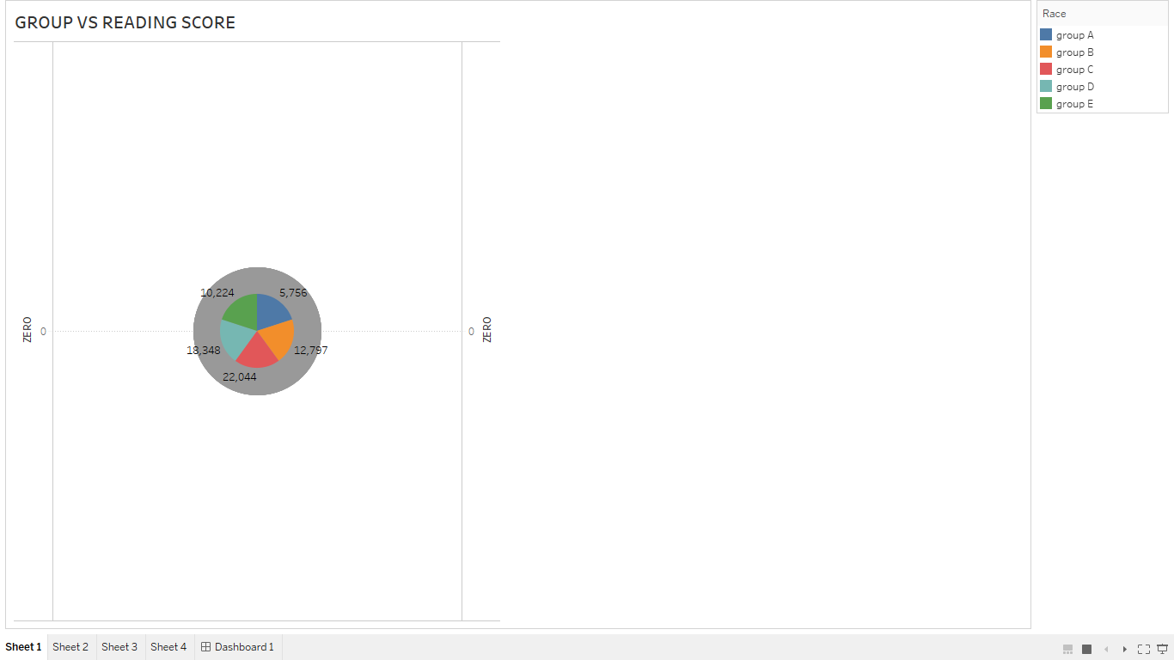

**DASHBOARD:** 